Data Consistency
OutreachData foreign key check
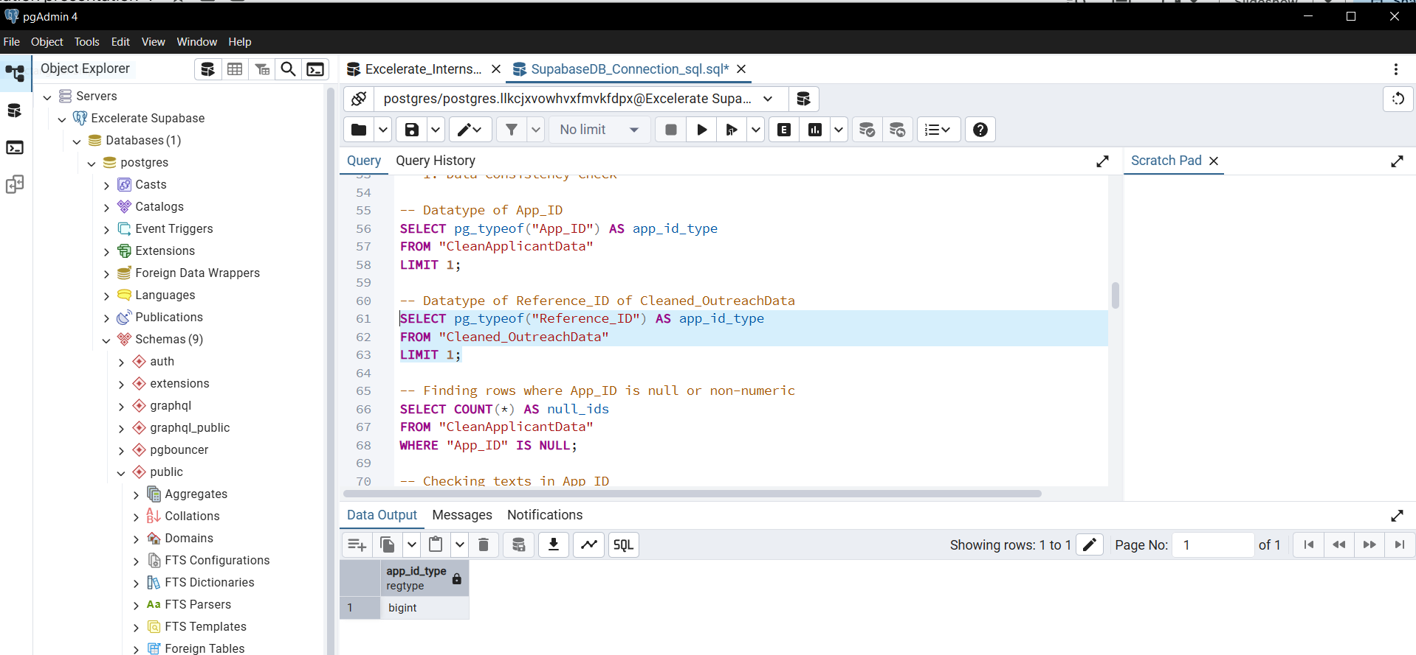
CleanApplicantData primary key check
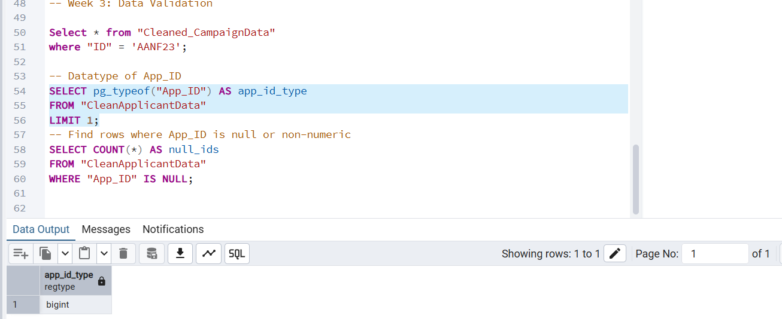
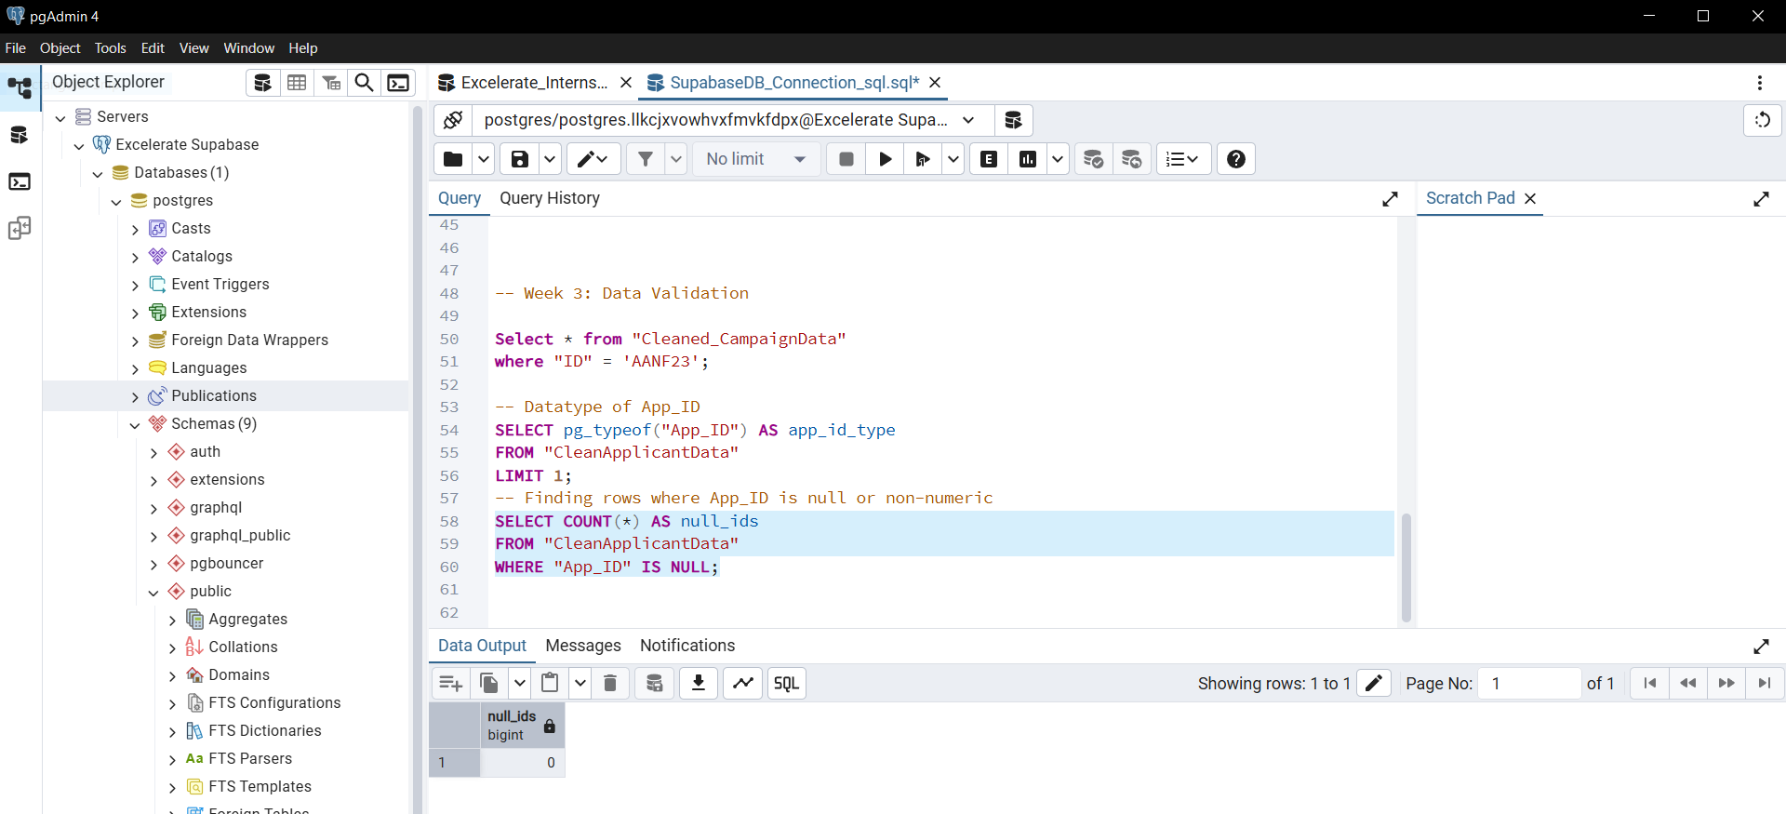
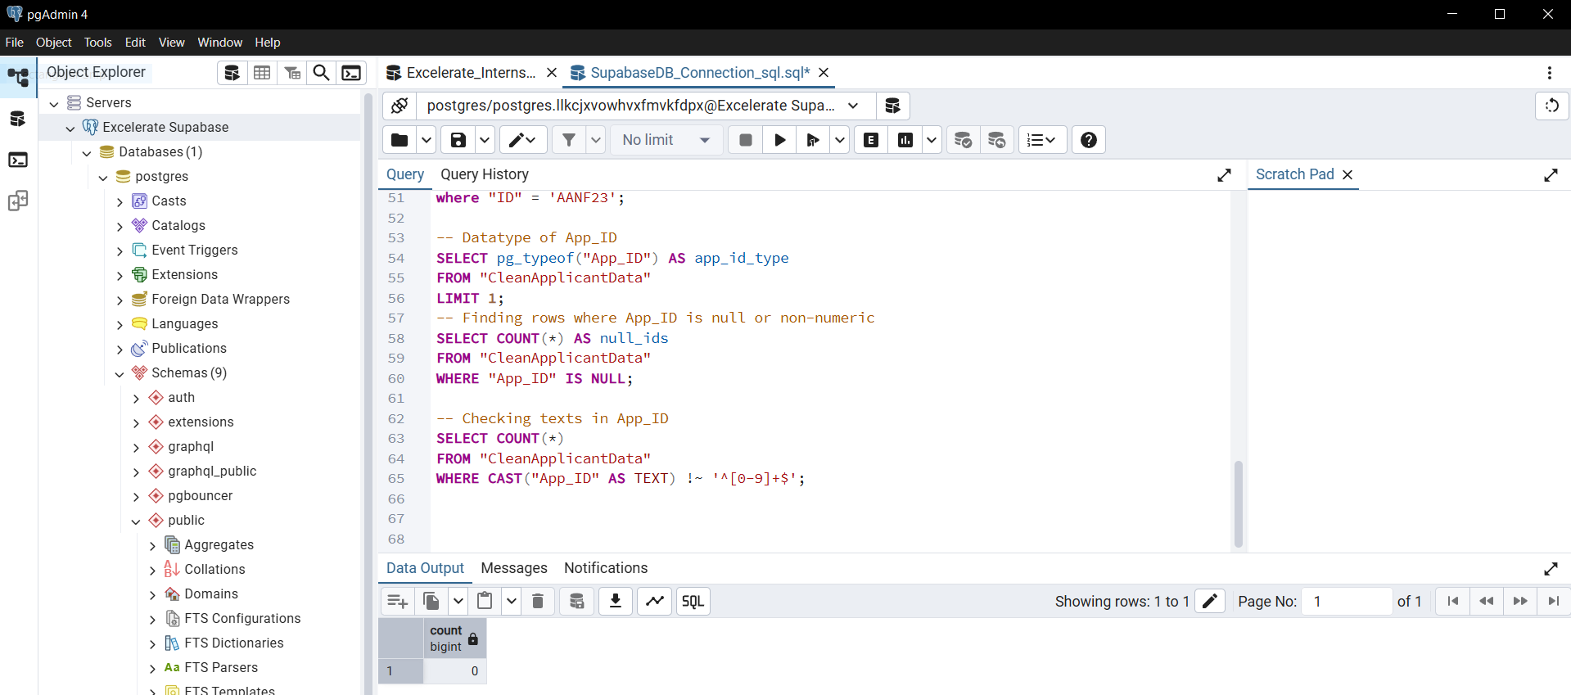
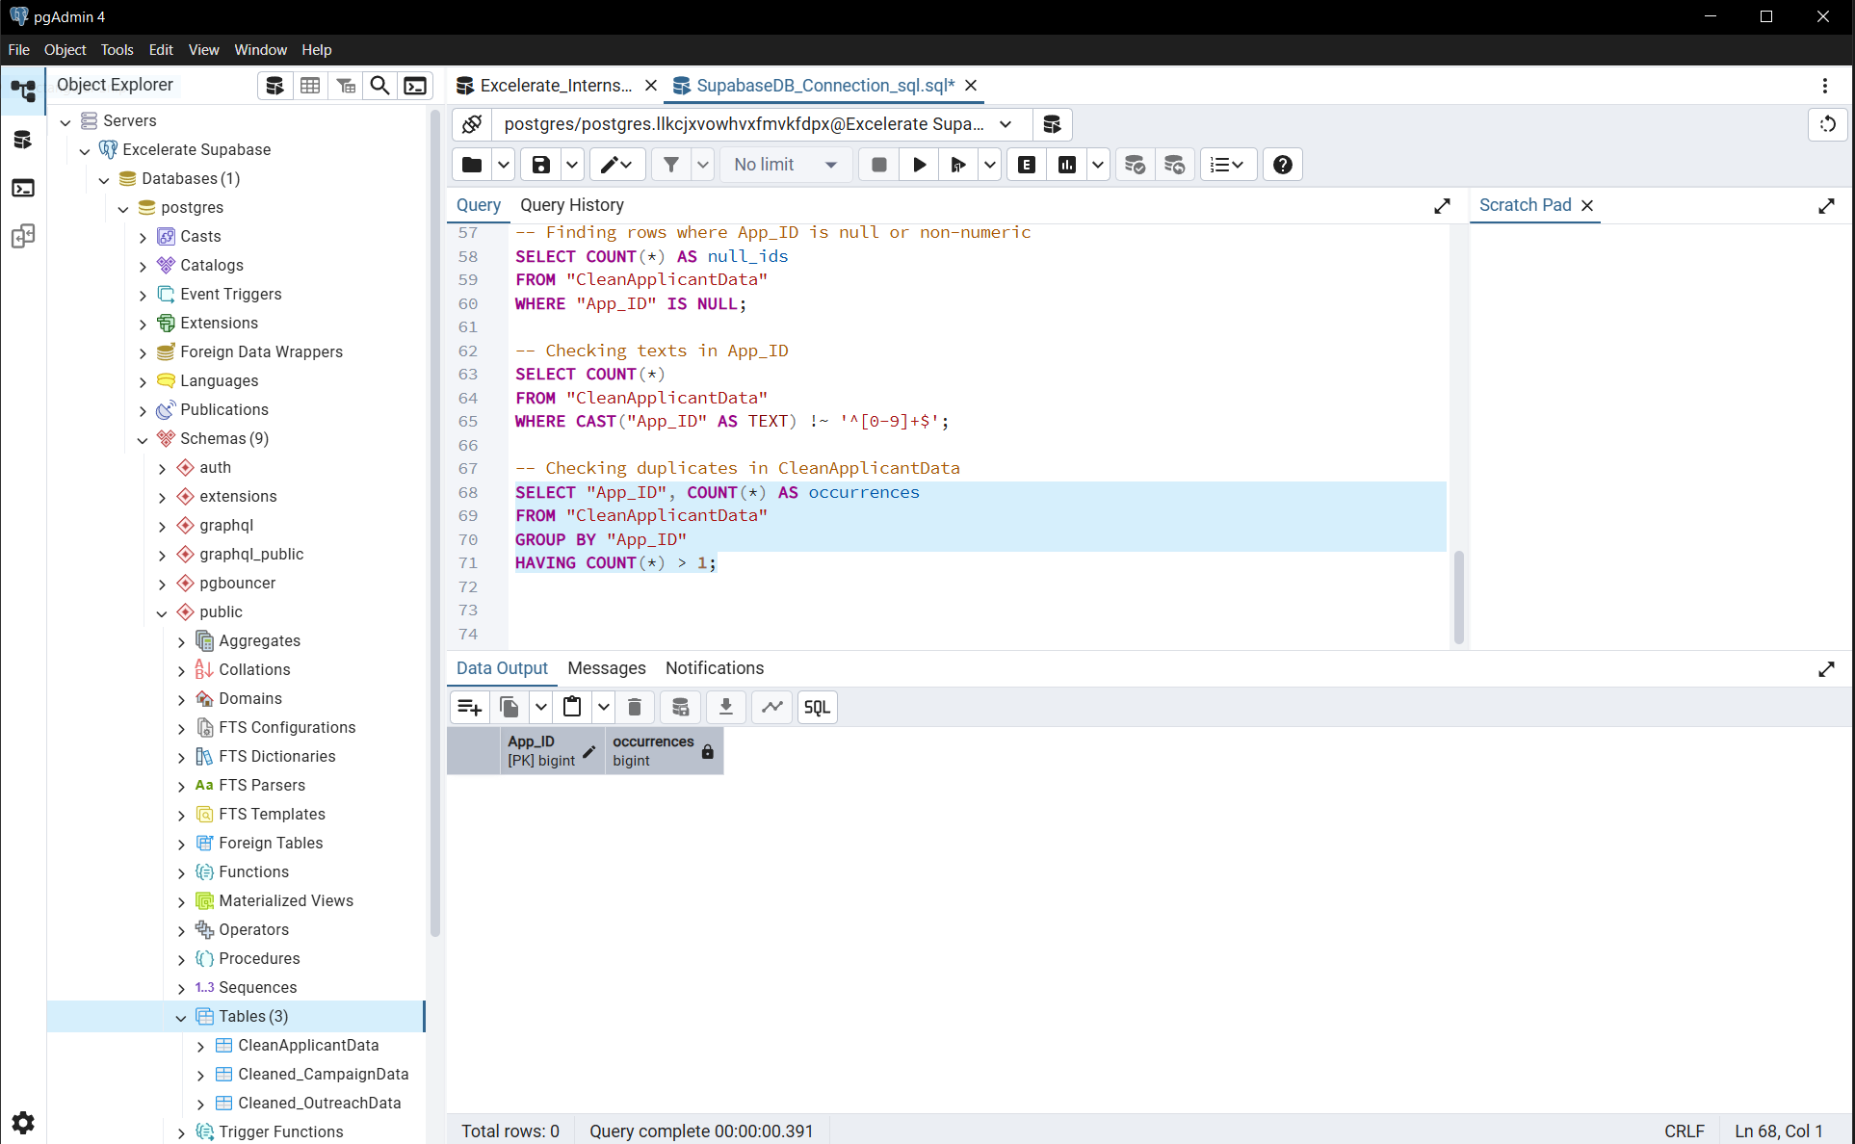
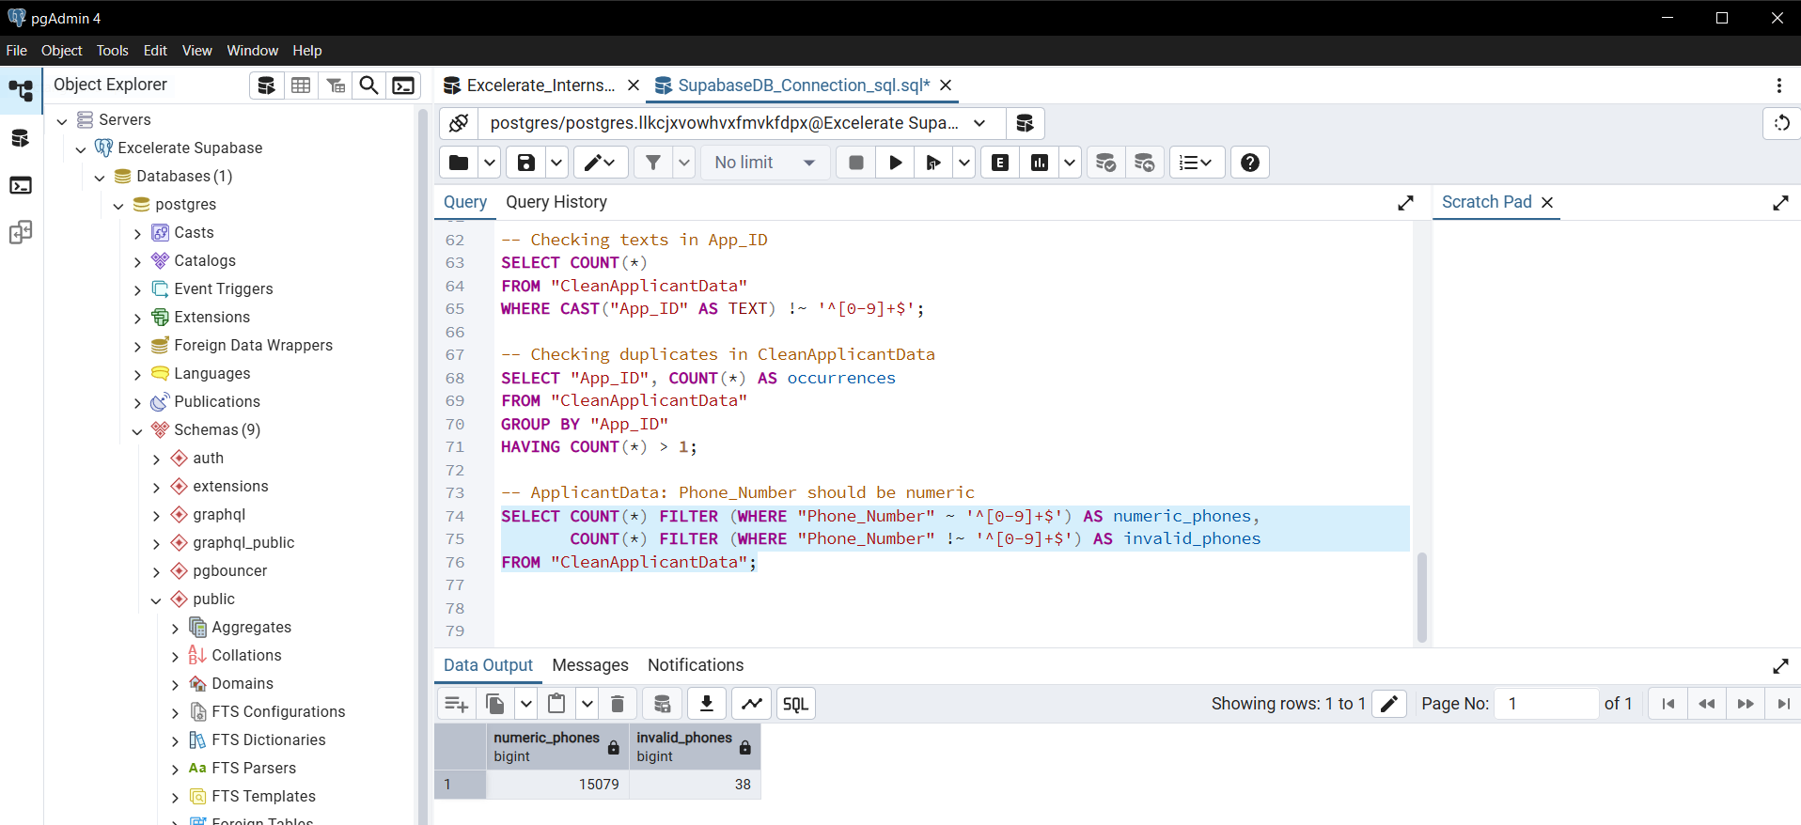

Timestamp checking
Campaign data
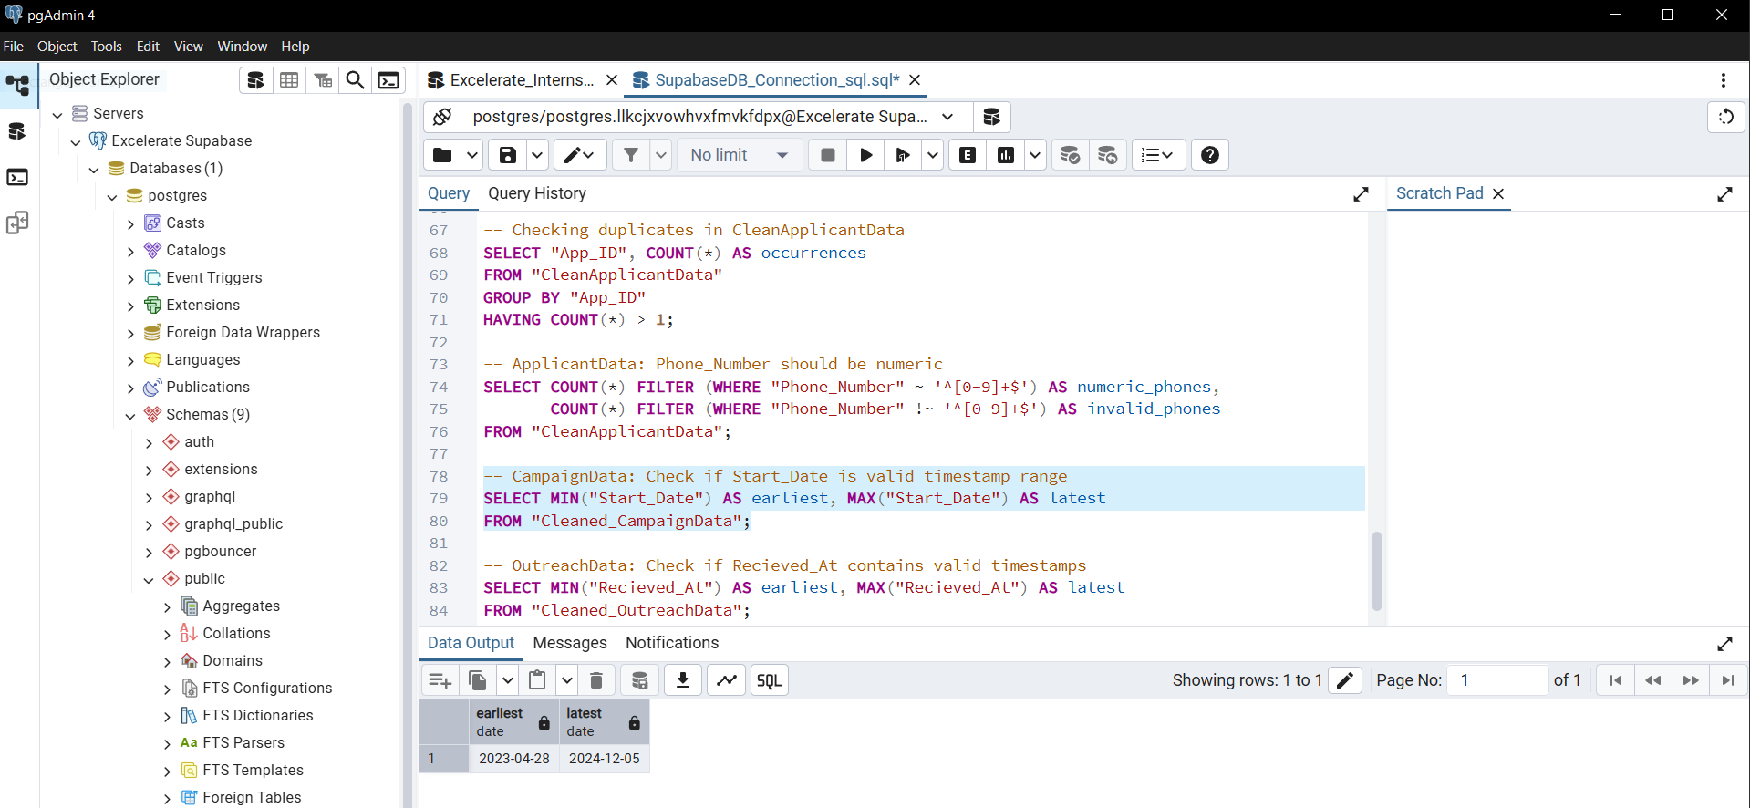

OutreachData
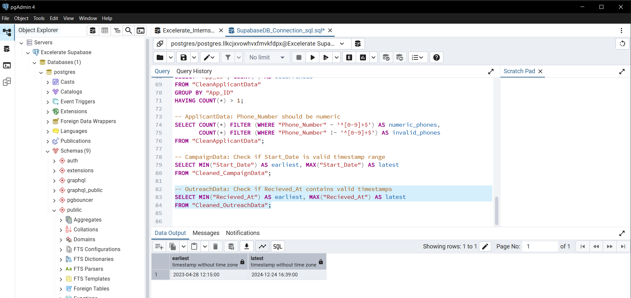
Campaign_Id of outreachdata is completely correlated with campaign’s ID
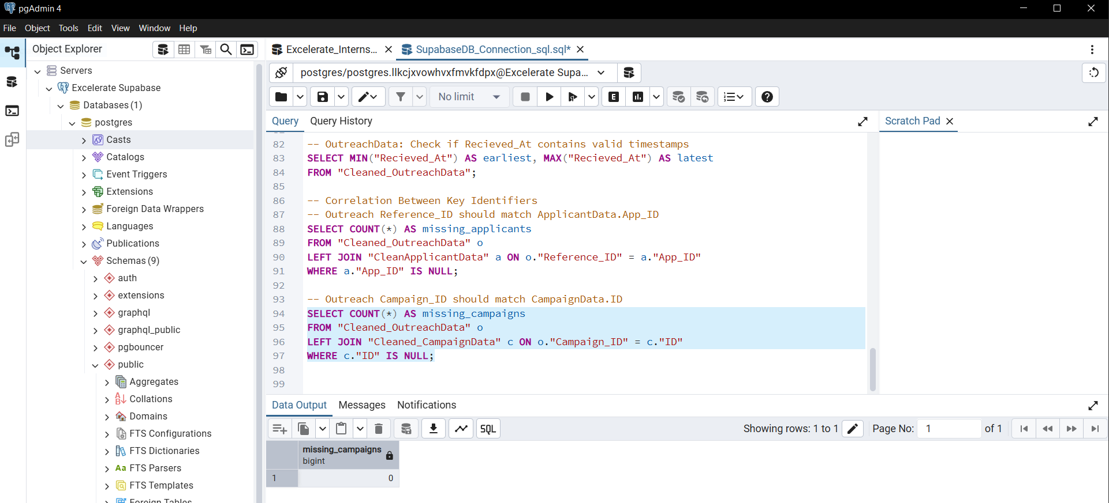

42 app_id missing after left join
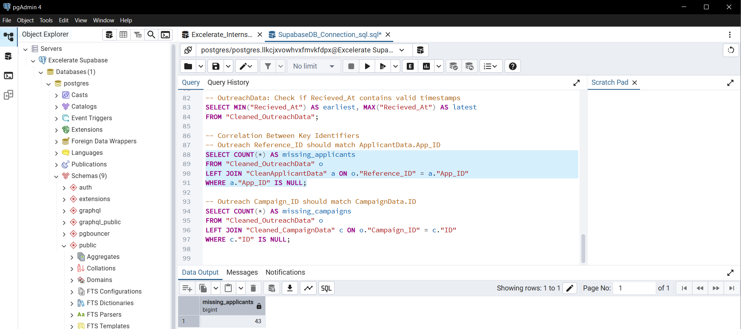
Valid app_id’s 33076
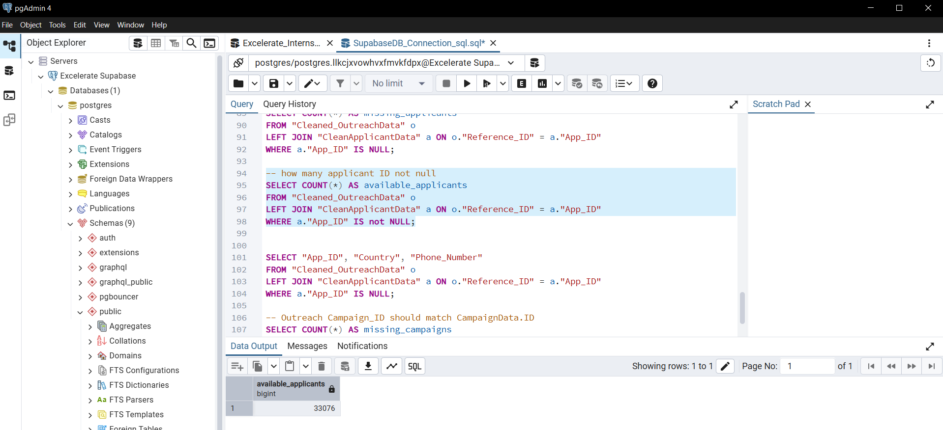

checking other informations of those null app_id's
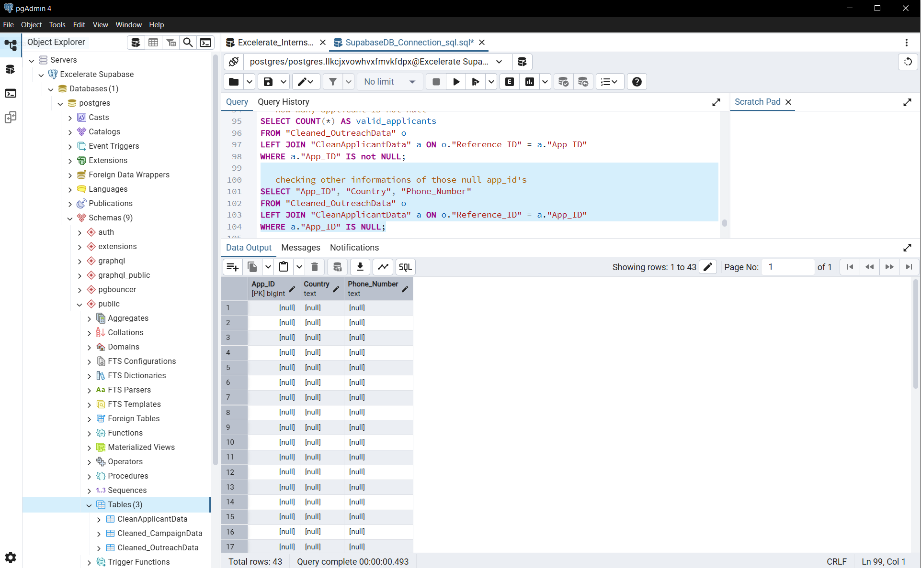
So, all other fields are also null.
1. Out of all outreach records, 42 records referenced invalid applicant IDs that did not exist in the Applicant dataset.
2. These represent ~0.1% of the total (42 / (33076+42)), which is statistically insignificant for overall trends.
3. For the current analysis and visualizations, these records were excluded to maintain data consistency.
4. Future work may involve:
- Investigating why these IDs are missing (data entry error, system issue, external applicants).
- Either removing them permanently or fixing them if correct references can be found.

Completeness Verification
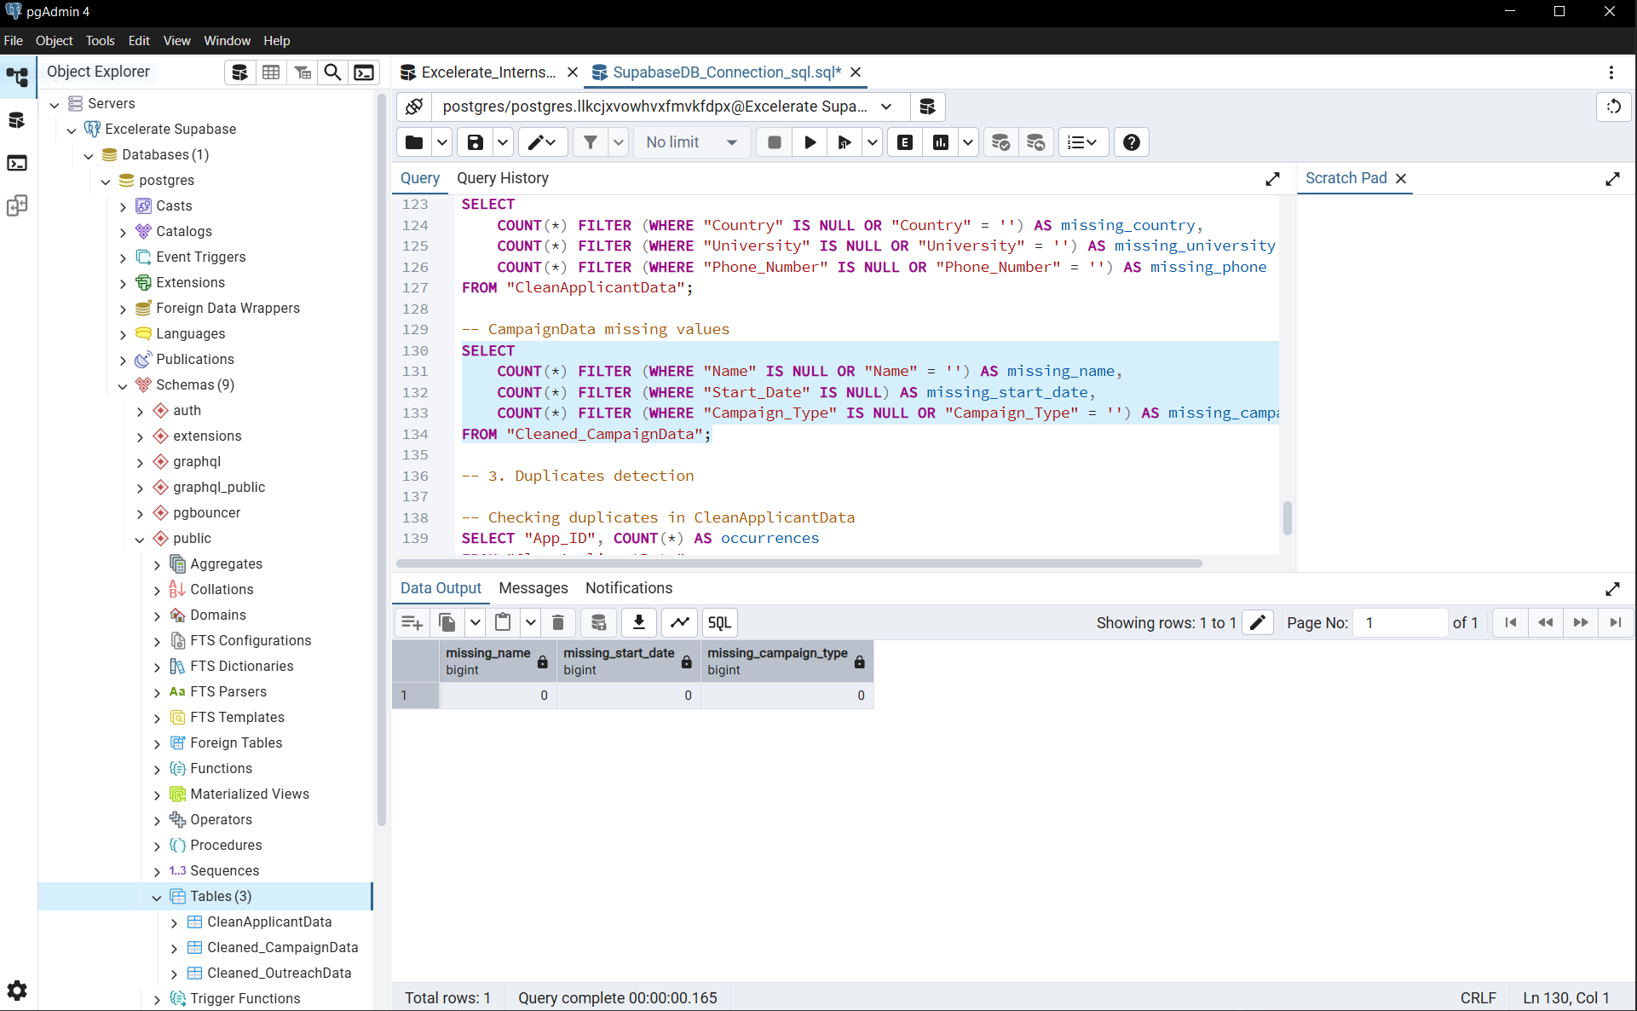

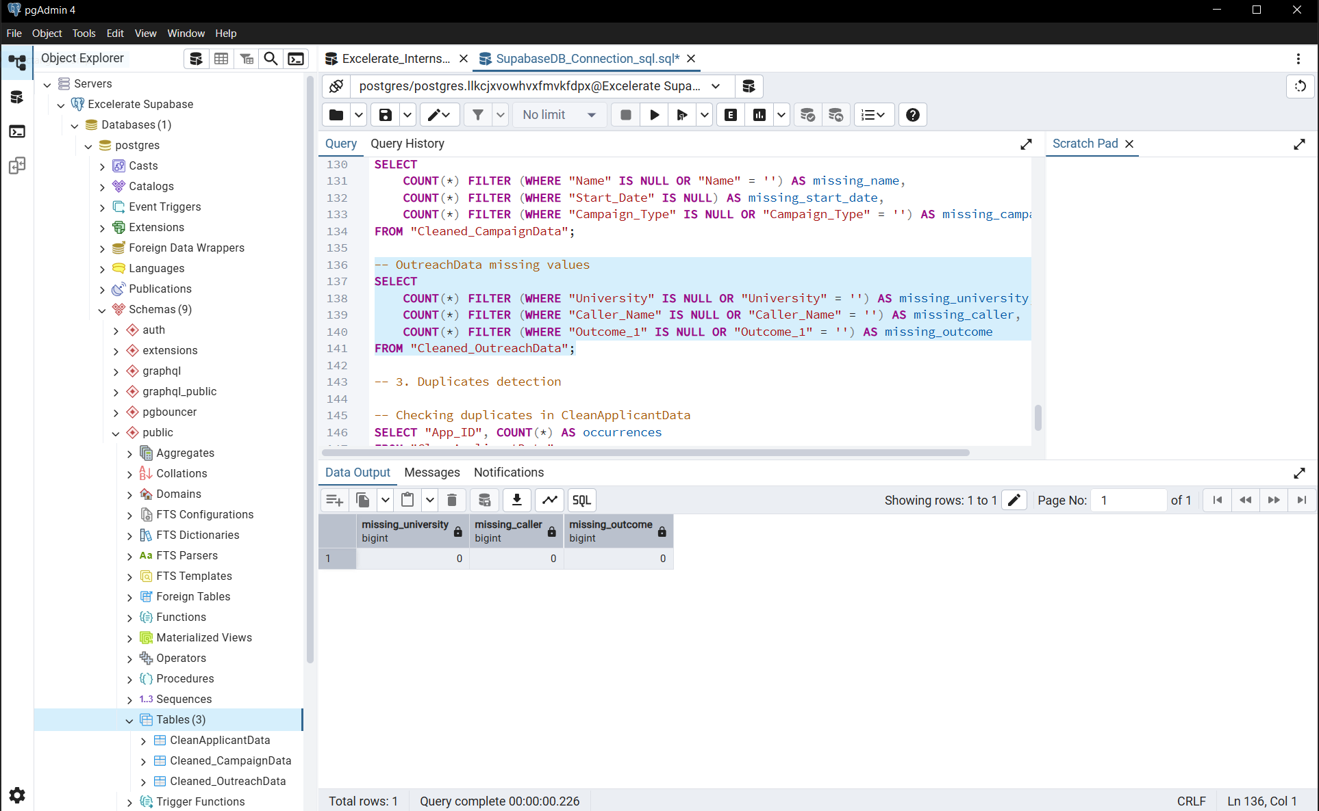

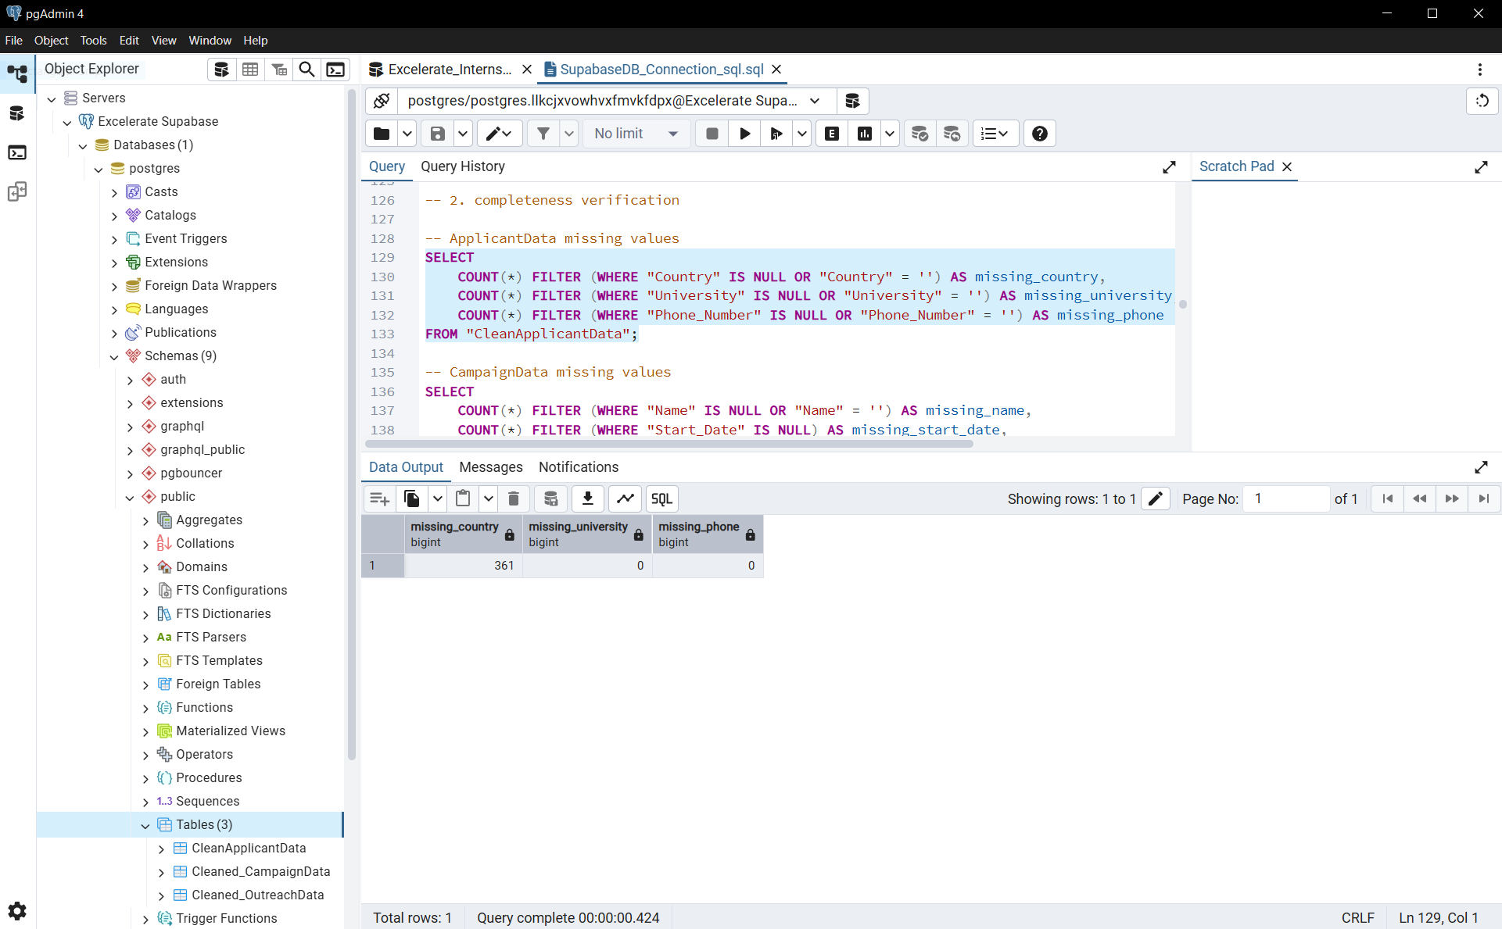

Duplicate Detections
CampaignData’s ID
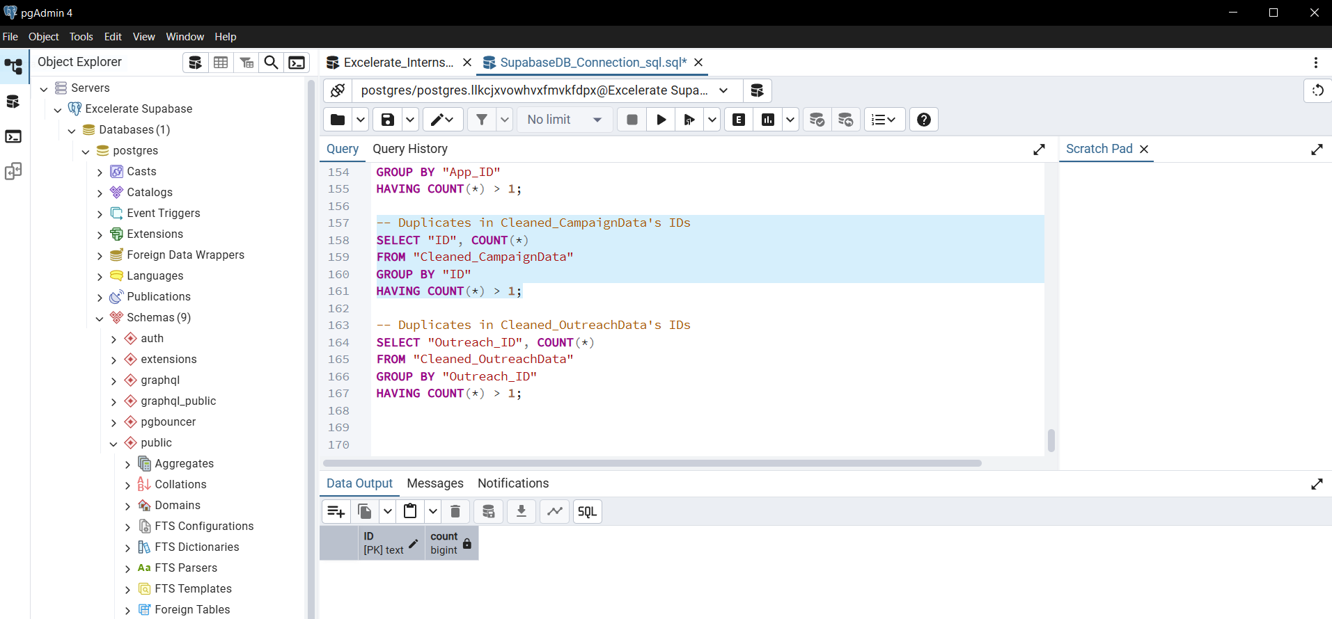
ApplicantData’s App_ID
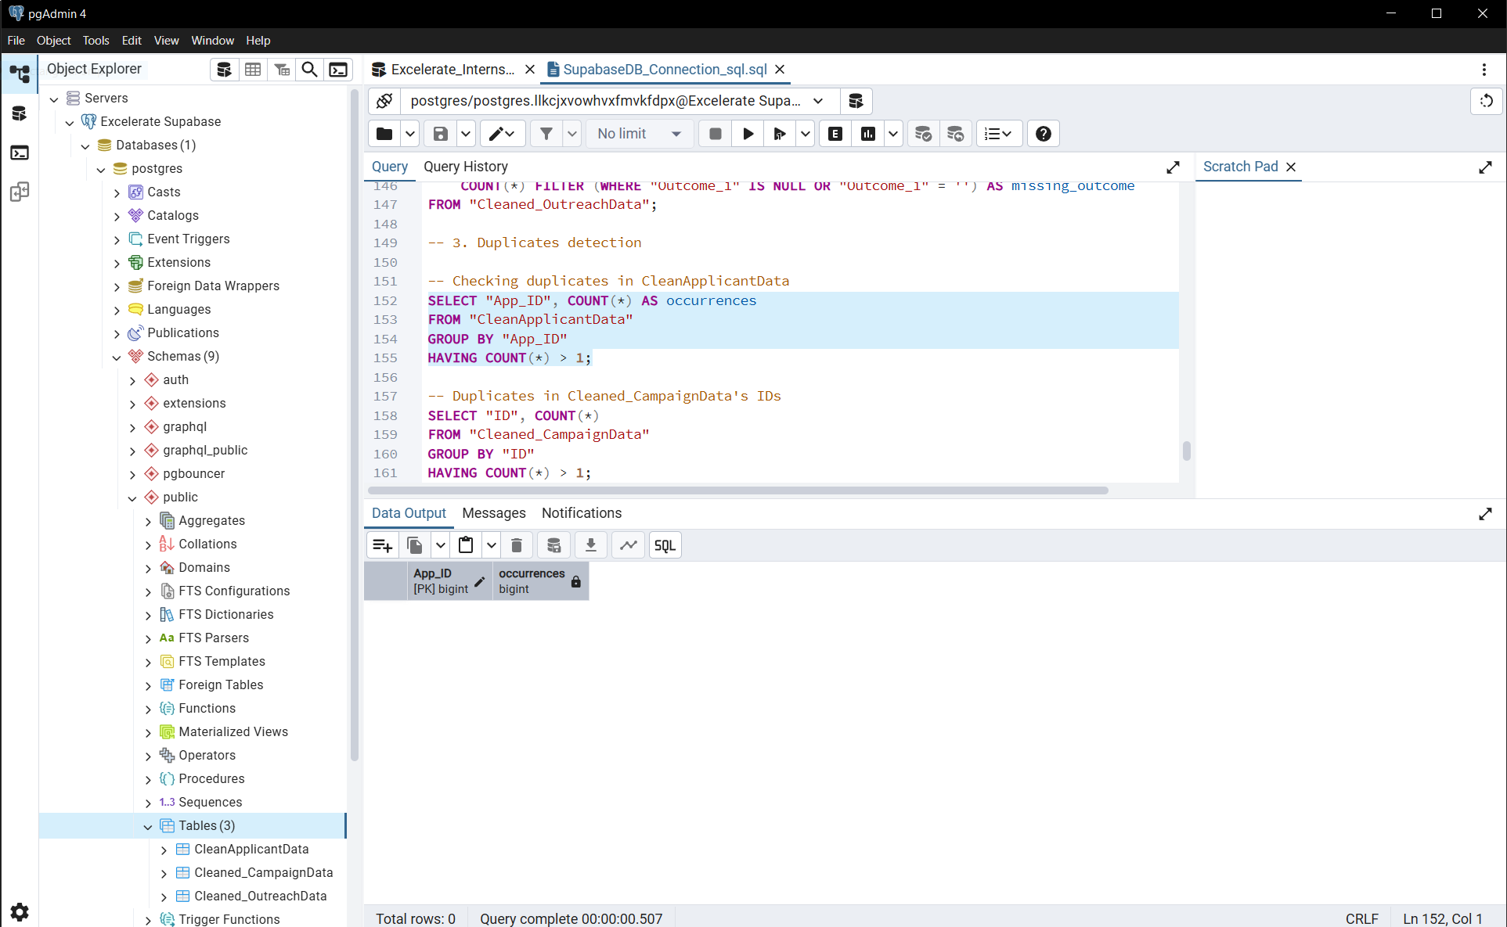

Reference_ID is a foreign key. So duplicates are normal
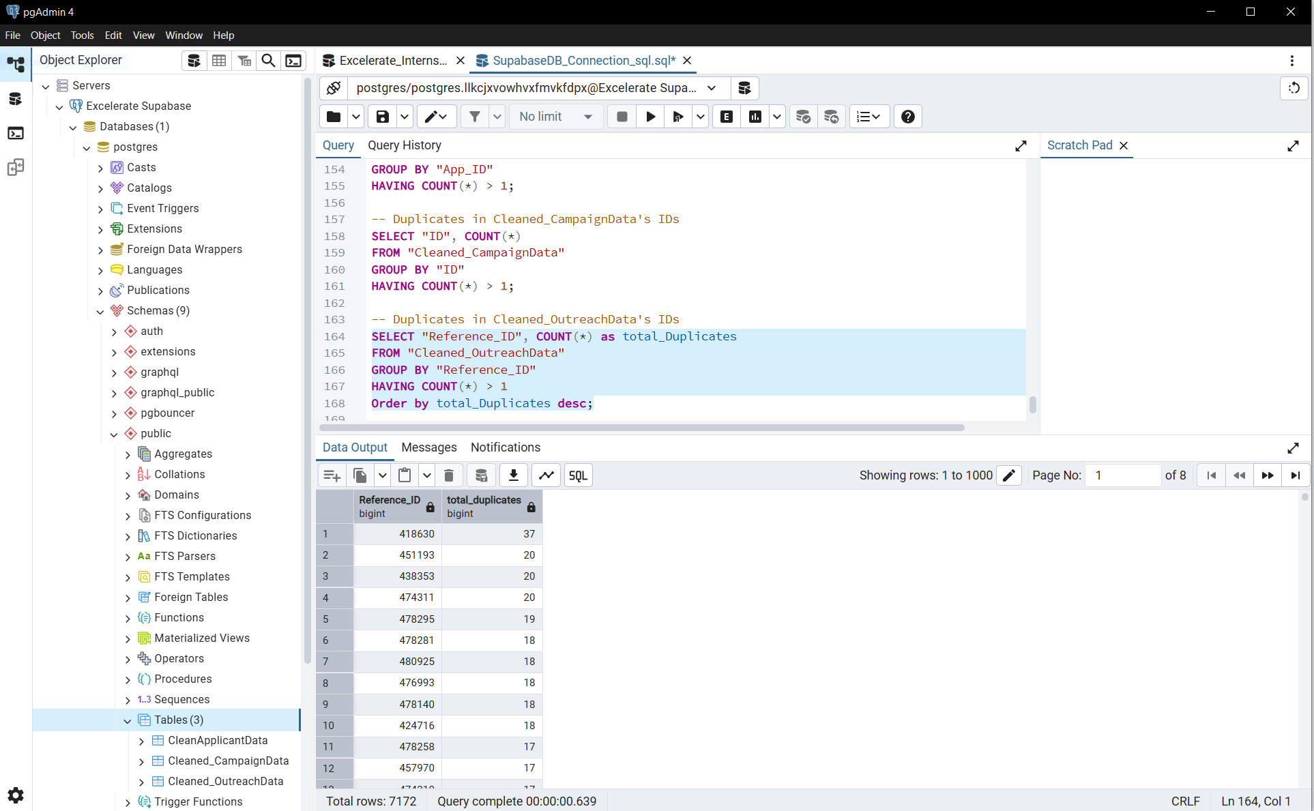
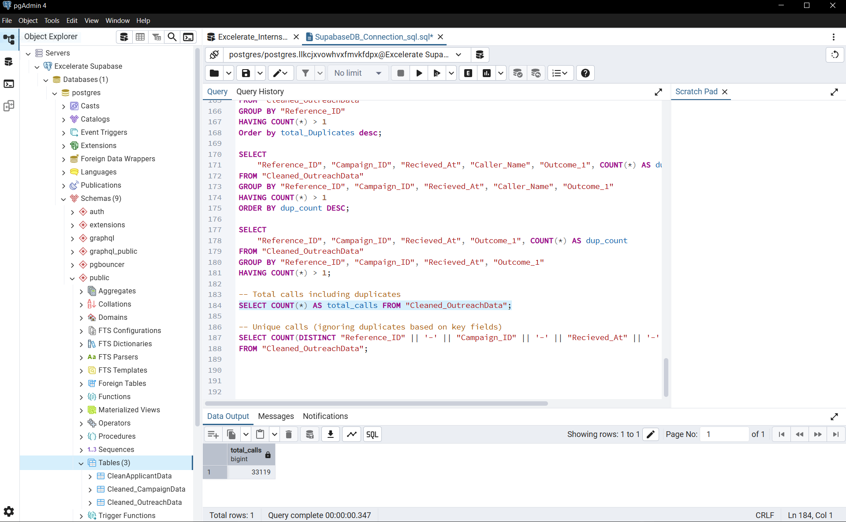
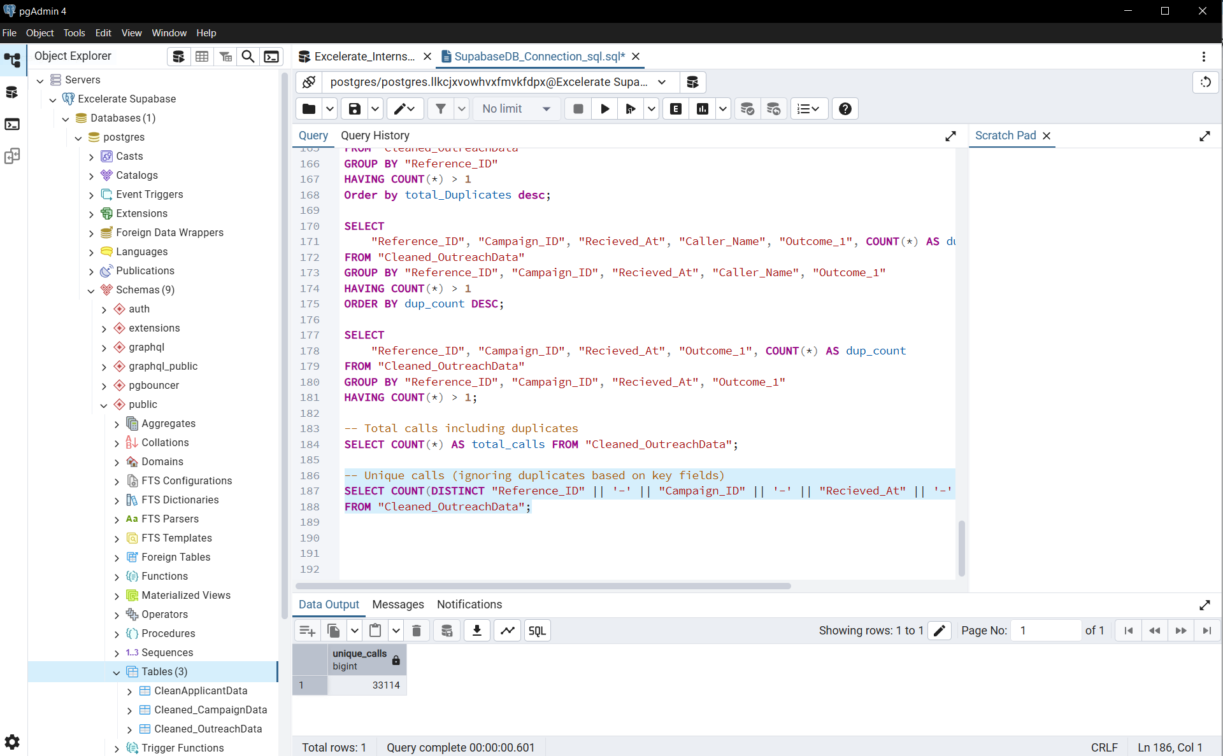

Business Rule Validation
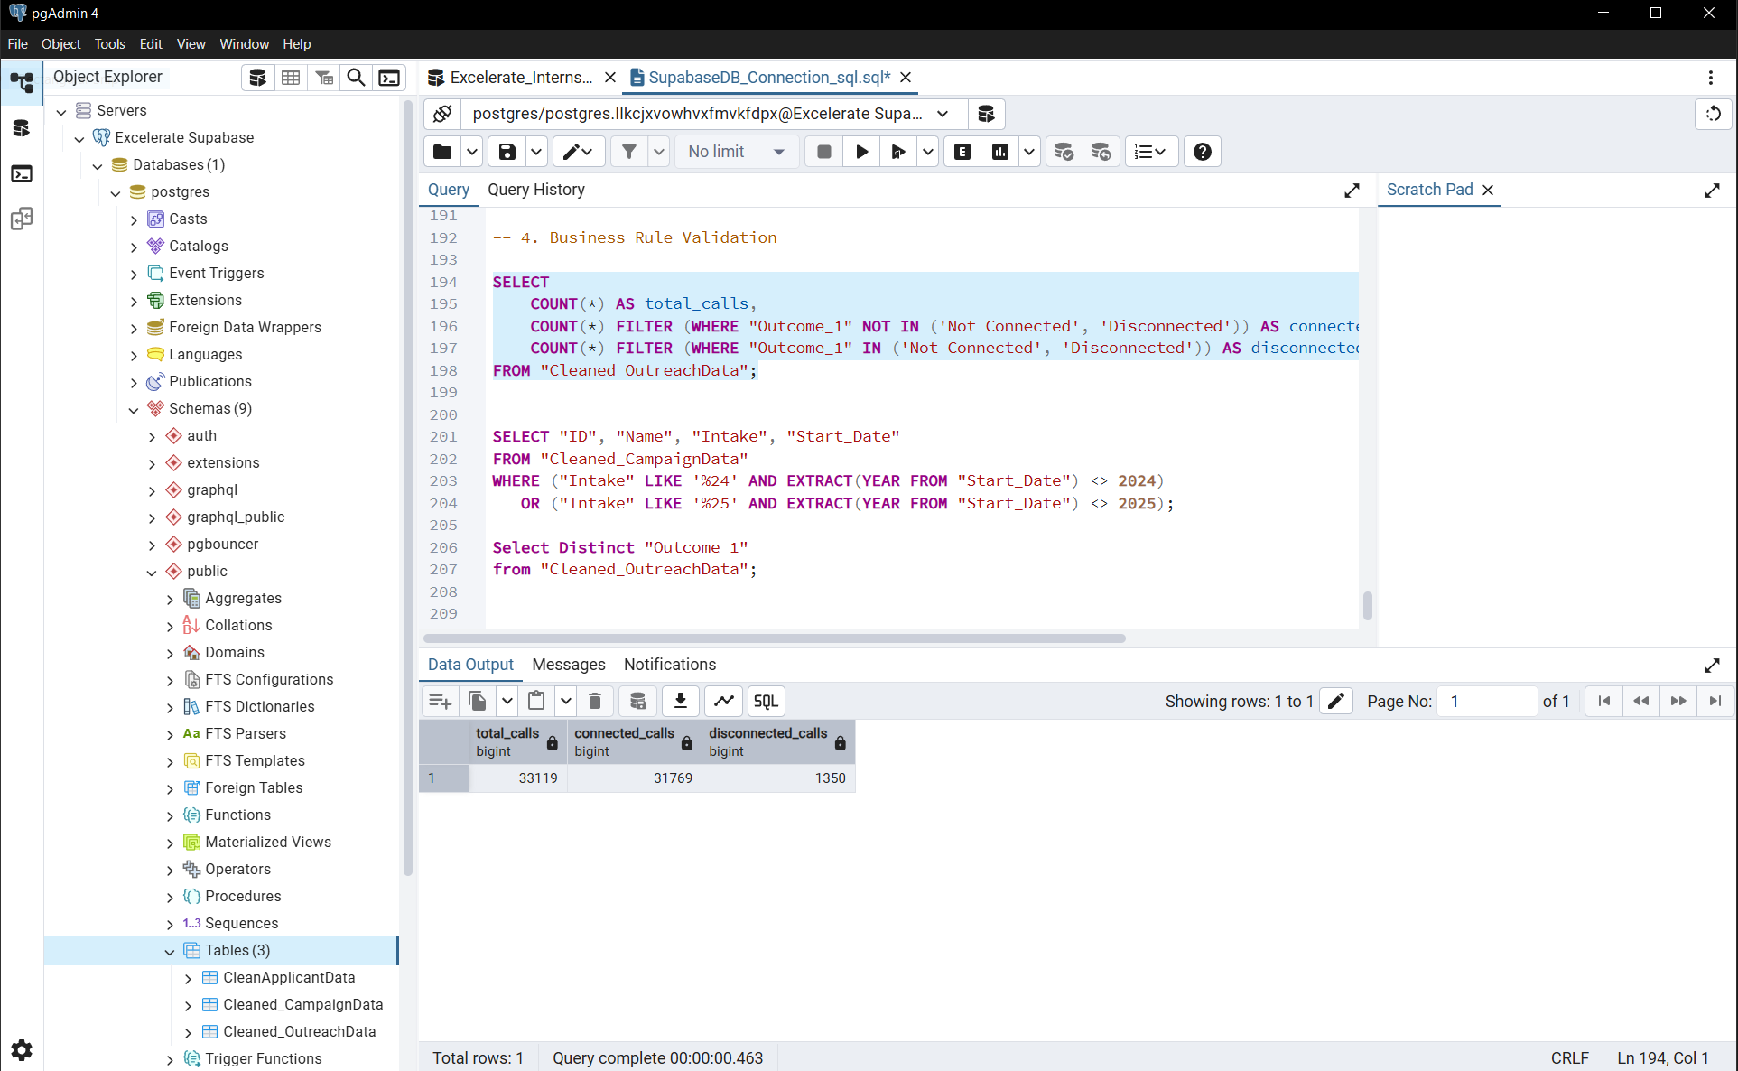
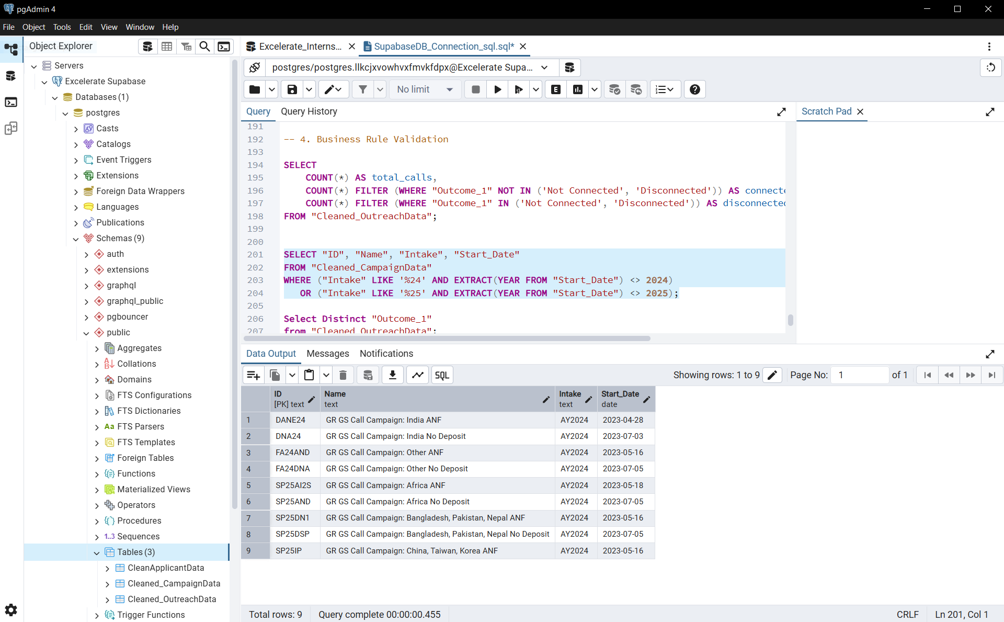

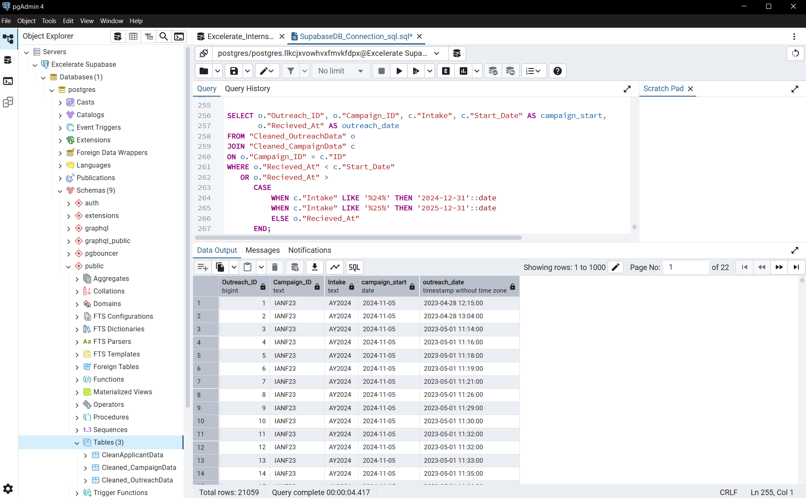
Campaigns for intakes FA24 and SP25 were planned for 2024 and 2025 respectively.
However, outreach and marketing activities began earlier, with some Start_Dates in 2023.
This is consistent with marketing practice and does not represent a data error.
Business rule validation confirms that no campaign Start_Date exceeds its intake year range.
Campaigns for intakes FA24 and SP25 were scheduled for 2024 and 2025, respectively.
Outreach and marketing activities, however, began earlier, with some Start_Dates in 2023.
This is consistent with standard marketing practice and does not indicate a data error.
Business rule validation confirms that no campaign Start_Date extends beyond the expected intake year range.

Campaigns for intakes FA24 and SP25 were planned for 2024 and 2025, respectively. Outreach and marketing activities began earlier, with some Start_Dates in 2023, which is consistent with standard marketing practice and does not indicate a data error.
Business rule validation confirms that no campaign Start_Date exceeds its intake year range. Additionally, outreach records that fall outside the expected campaign timeframe are flagged, showing the Outreach_ID, Campaign_ID, intake, campaign start date, and actual outreach date. This allows identification of any outreach performed before the official campaign launch or after the intake period.

